**PES University, Bangalore**

**(Established under Karnataka Act No. 16 of 2013)**

**Department of Computer Science and Engineering**

**UE21CS351B : Cloud Computing**

**Assignment – 2**

**Manasi Tawade**

**Section D**

**PES1UG22CS815**

1a.jpg: Screenshot of running docker hello-world.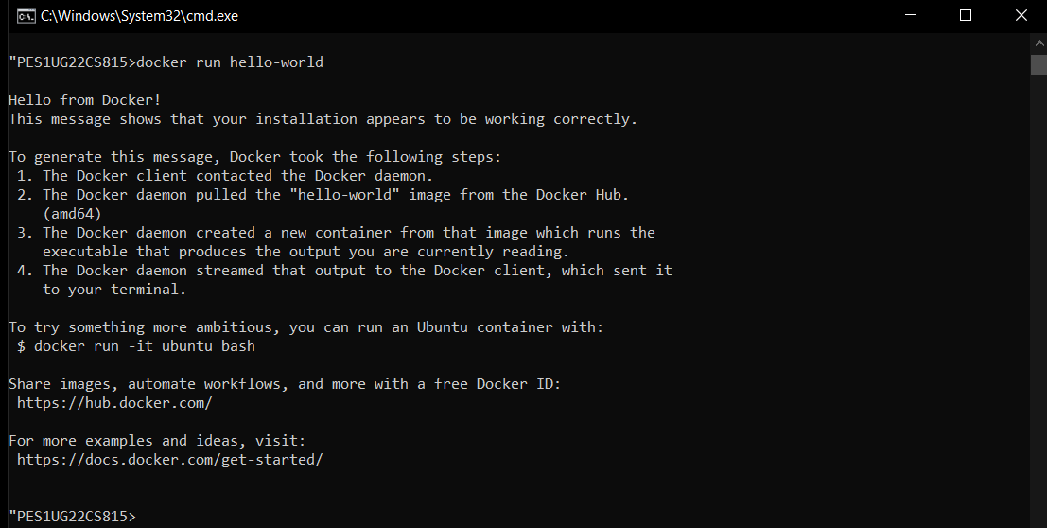

2a.jpg: Screenshot of python-mongodb application running as a docker-compose application(logs of the application) 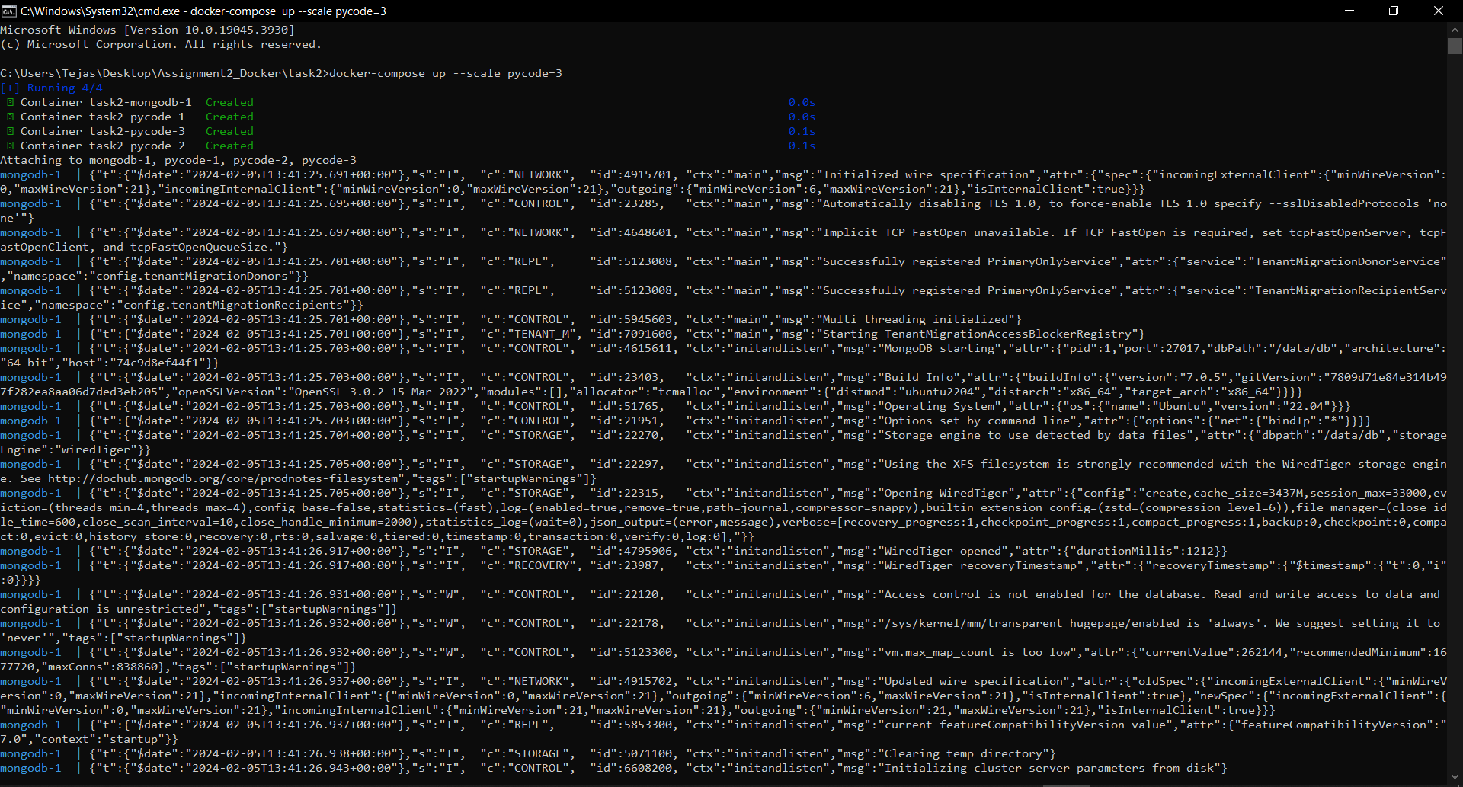

2b.jpg: Screenshot of 3 python application writes and reads from MongoDB after scaling the python application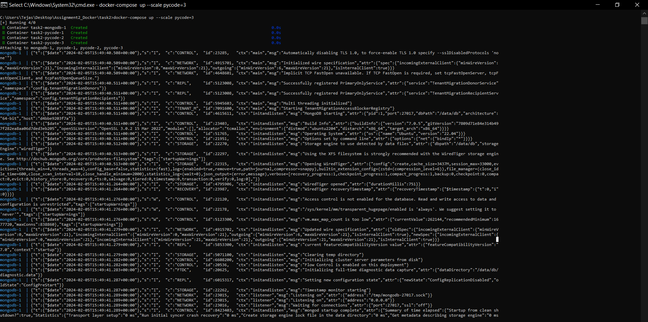

3a.jpg: Screenshot of docker container running nginx 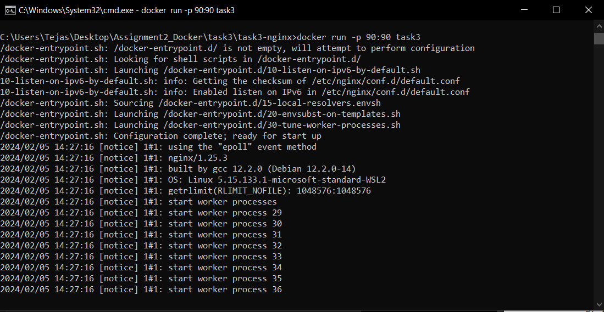

3b.jpg: Sample.html showing the web page on the browser. 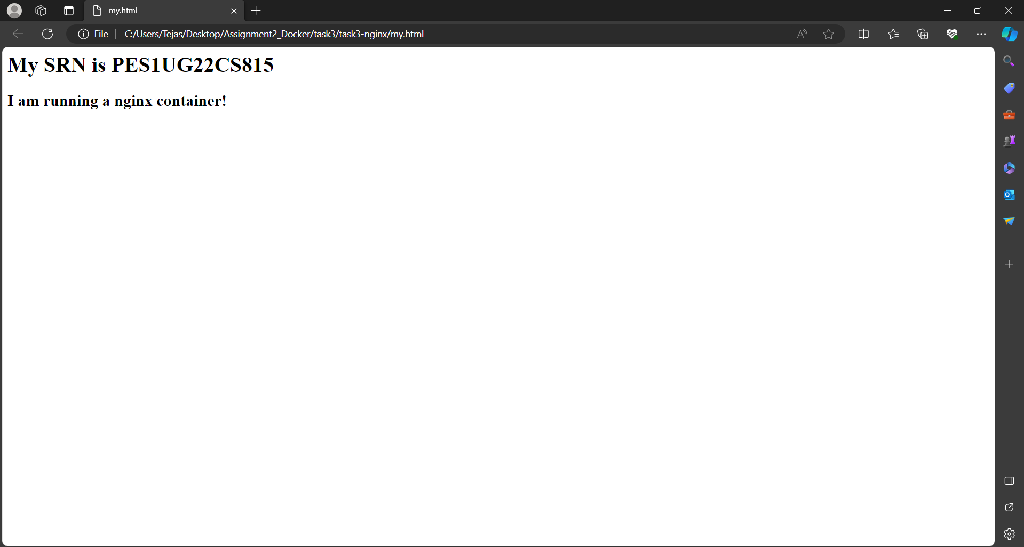

3c.jpg: Screenshot of python application successfully writing and reading from the MongoDB database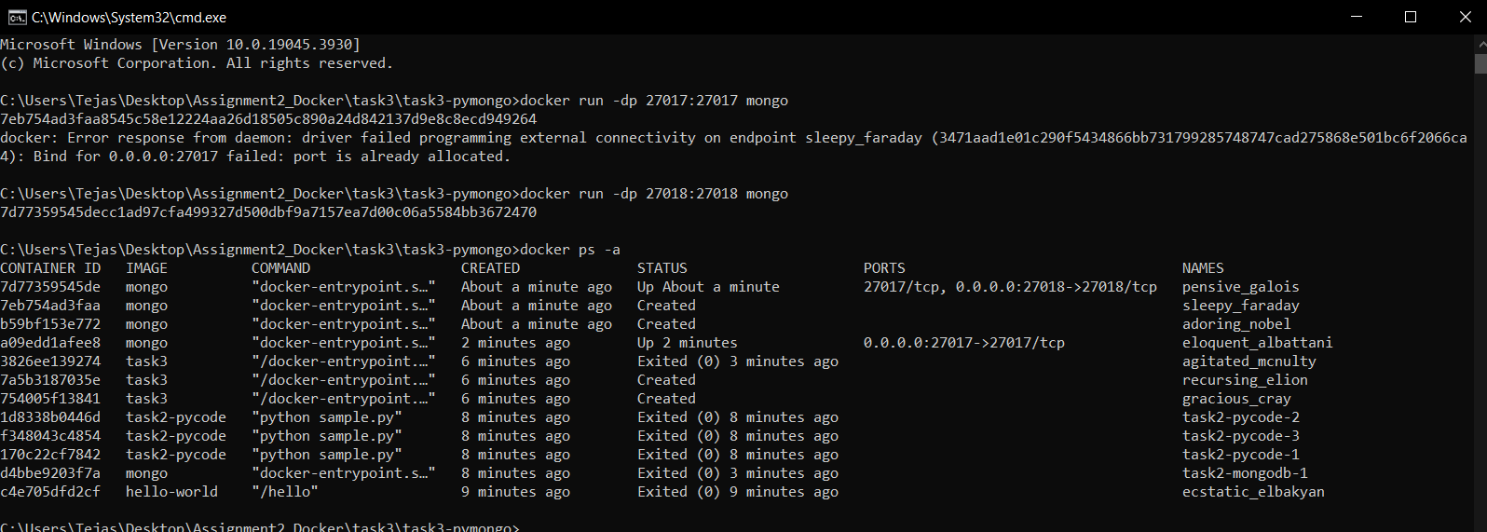3d.jpg: Screenshot showing mongodb being run within the network(docker command has to be clearly highlighted) 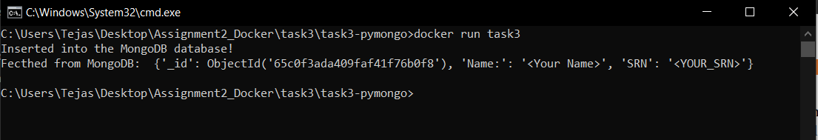

3e.jpg: Screenshot showing python file being run within the network and successfully writing and reading from MongoDB(docker command has to be clearly highlighted) 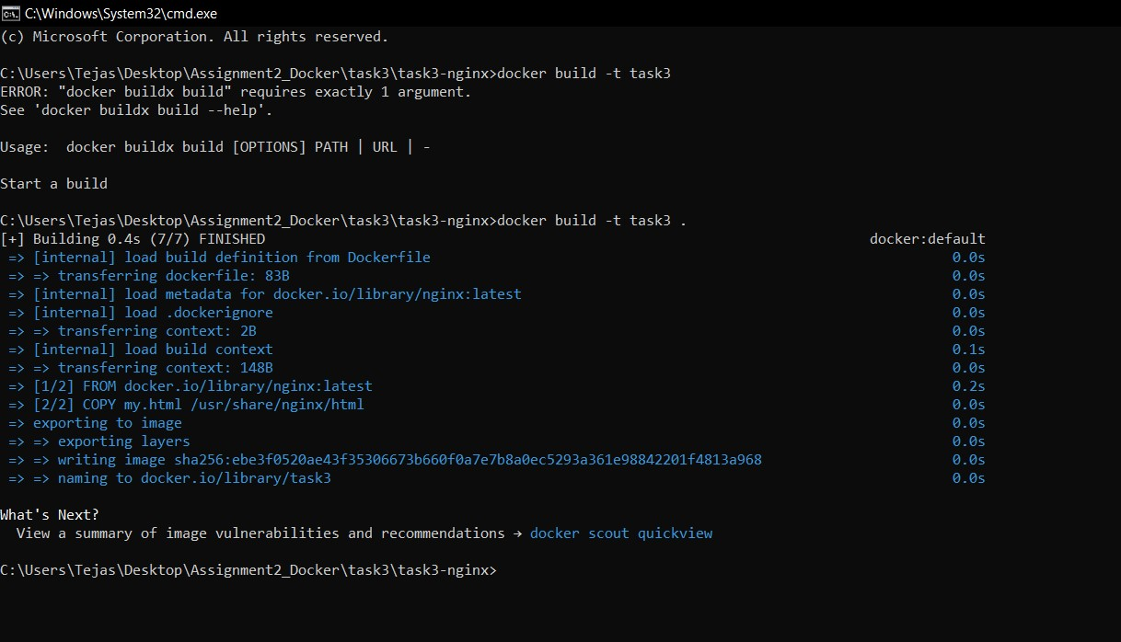

4a.jpg: Screenshot of C Program successfully run inside the container. 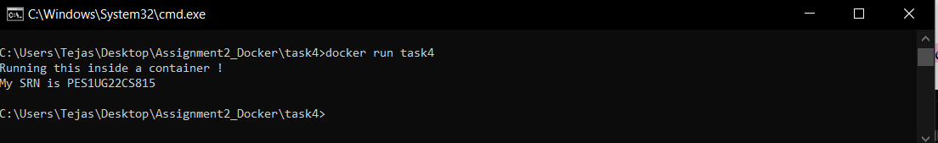4b.jpg: Screenshot of the image pushed to Dockerhub. 